

**Business Intelligence Project**

|  |
| --- |
| **Functional Specifications**  **Flash Furnace Area** |

|  |  |  |  |
| --- | --- | --- | --- |
| **Release** | **Date** | **Release alias** | **Author** |
| 000 | 10/06/2013 | Draft | VIX Helene |
|  |  |  | VIX Helene |
|  |  |  |  |
|  |  |  |  |
|  |  |  |  |
|  |  |  |  |

**CONTENTS**

1. Introduction and Context 3

1.1 Project’s participants 3

1.2 Purpose of the document 3

1.3 Project’s purpose 3

1.4 Project’s background: the flash furnace process 4

2. Typology of needs 4

3. Axis of analysis (Dimensions) 5

3.1 Axis of period 5

3.2 Axis of production day 6

3.3 Axis of scenario 6

3.4 Axis of shift 7

3.5 Axis of parameter 7

3.6 Axis of task 8

3.7 Axis of task’s department 8

3.8 Axis of task frequency 8

3.9 Axis of task type 9

3.10 Axis of task status 9

3.11 Axis of employee 9

3.12 Axis of event type 10

3.13 Axis of discipline 10

3.14 Axis of TUC 10

3.15 Axis of source asset 11

3.16 Axis of reason 11

4. Measures 12

4.1 Measures of FSFE parameters 12

4.2 Measures of FSFE tasks 12

4.3 Measures of FSFE production 13

4.4 Measures of FSFE slowdowns & downtimes 14

5. Scope of measures 15

6. Reports 16

6.1 FSFE daily process review 16

6.2 FSFE weekly process review 16

6.3 FSFE monthly process review 17

6.4 FSFE daily off-gas handing review 17

7. Prioritization of needs 18

# Introduction and Context

## **Project’s participants**

PASAR functional stakeholders:

|  |  |
| --- | --- |
| Nap A. Nepomuceno | Senior Process Engineer |
| Jason S. Meralles | Process Engineer |
| Rachelle Mae S. Tuble | BI Expert |

PASAR technical stakeholders:

|  |  |
| --- | --- |
| Russel K.L. tan | IT Specialist |
| Andrian R. teleron | IT Applications Support Manager |
| Mark Yap | AVP – Information Technology |

Data For Action stakeholder:

|  |  |
| --- | --- |
| Helene VIX | BI Consultant |

## **Purpose of the document**

The purpose of the document is to specify reports and analysis cubes that will be deployed as part of the project for the Flash Furnace area.

## **Project’s purpose**

The purpose of this BI pilot project is to setup an **MS BI application** for monitoring the FSFE process as well as the FSFE production.

**Data perimeter**

The application will process data on process conditions, slowdowns, downtimes and taken actions for the FSFE area.

The application will collect these data from:

* the PI system,
* the LIMS (Laboratory system),
* the RTDuet database,
* the Action Tracker database.

In term of history, the application will process data from May 1 2015 (**to be confirmed**).

**Users’ perimeter**

The following people will access to the BI FSFE platform:

* Nap A. Nepomuceno (PASAR Senior Process Engineer) – Consumer role
* Jason S. Meralles (PASAR Process Engineer) – Consumer role
* Ramanathan Muthuraman (PASAR Process SVP) – Consumer role
* Joven Chiong (PASAR Process AVP) – Consumer role
* Rachelle Mae S. Tuble (PASAR BI Expert) – Key user role

## **Project’s background: the flash furnace process**

The purpose of the FSFE process is to provide Matte to feed the Converter furnace with minimum copper loss in the FSFE granulated slag.

**Diagram of the process**

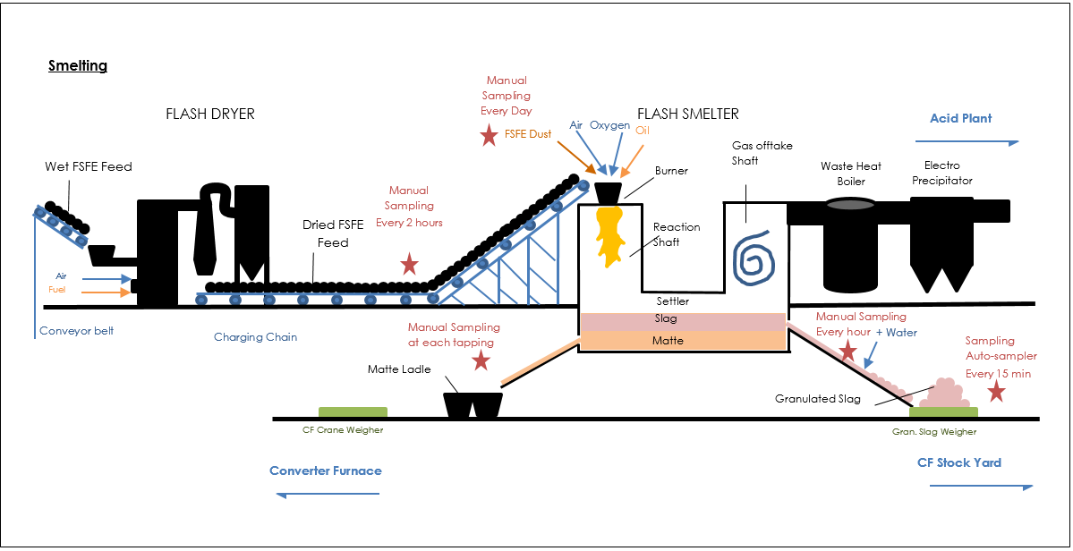

**Impact of expansion project on the FSFE process**

After the expansion project, the produced Matte grade will be increased from 52% to 62% thanks to increase of Oxygen Plant capacities.

The new Flash Furnace will no longer use electrodes and the slag will no longer be granulated: the FSFE Slag will be transported into pots and will stay in pot for 24/48 hours before being treated in the Slag Flotation Plant.

**Special point of attention for the FSFE process**

As the FSFE process is continuous, process data and results must be reconciled within a consistent time range.

As the main assignment of the FSFE process is to provide Matte to the Converter Furnace, time lags for all FSFE parameters are defined against to the Matte tapping.

# Typology of needs

Four kinds of needs have been raised during the interviews:

- monitor the performance of the FSFE process on a daily, weekly and monthly basis,

- monitor the FSFE production on a daily, weekly and monthly basis,

- highlight the FSFE process performance with plant availability,

- report the taken actions in the FSFE area during the day, the week or the month.

# Axis of analysis (Dimensions)

An analysis axis shows the context of an event (slowdown, downtime, FSFE process in this case).

Some dimensions may include hierarchies; this means some members of this dimension can be grouped in others members (for example days can be grouped by month that can be grouped by year).

## **Axis of period**

The axis of period represents:

* start date and start time of slowdowns and of downtimes,
* end date and end time of slowdowns and of downtimes,
* timestamping of recorded FSFE parameters.

Leaf level: Date Time (*Identity*: DATETIME_ID, *Alias*: DATETIME_ALIAS)

Visualization of hierarchies

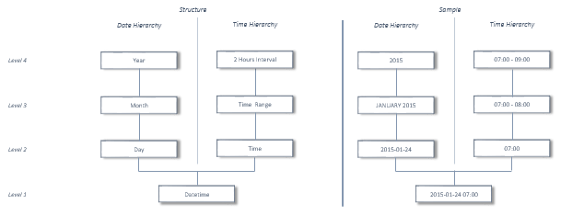

Definition of the Date hierarchy

|  |  |  |  |  |  |  |  |
| --- | --- | --- | --- | --- | --- | --- | --- |
| **Level** | **Description** | **Definition** | **Parent Level** | **Structure** | | **Sample** | |
| **Identity** | **Alias** | **Identity** | **Alias** |
| 1 | DateTime | Date and time of the event | 2 | DATETIME_ID | DATETIME_DATE | 201501240700 | 2015-01-24 07 :00 |
| 2 | Day | Day of the event | 3 | DAY_ID | DAY_DATE | 20150124 | 2015-01-24 |
| 3 | Month | Month of the event | 4 | MONTH_ID | MONTH_ALIAS + DAY_YEAR | 201501 | JANUARY 2015 |
| 4 | Year | Year of the event |  | DAY_YEAR | | 2015 | |

Definition of the Time hierarchy

|  |  |  |  |  |  |  |  |
| --- | --- | --- | --- | --- | --- | --- | --- |
| **Level** | **Description** | **Definition** | **Parent Level** | **Structure** | | **Sample** | |
| **Identity** | **Alias** | **Identity** | **Alias** |
| 1 | DateTime | Date and time of the event | 2 | DATETIME_ID | DATETIME_DATE | 201501240700 | 2015-01-24 07 :00 |
| 2 | Time | Time of the event | 3 | TIME_ID | TIME_ALIAS | 700 | 07 :00 |
| 3 | Time Range | Time range of the event | 4 | HOUR_ID | HOUR_ALIAS | 7 | 07:00 – 08:00 |
| 4 | 2 Hours Interval | 2 hours’interval of the event |  | 2HOUR_ID | 2HOUR_ALIAS | 7 | 07:00 – 09:00 |

## **Axis of production day**

The axis of production day represents all production periods of the FSFE process. A production day starts at 07:00 a.m. and ends the next day at 07:00 a.m.

Leaf level: Production Day (*Identity*: DAY_ID, *Alias*: DAY_ALIAS)

Visualization of the hierarchy

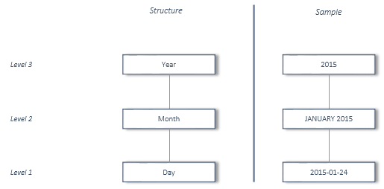

Definition of the hierarchy

|  |  |  |  |  |  |  |  |
| --- | --- | --- | --- | --- | --- | --- | --- |
| **Level** | **Description** | **Definition** | **Parent Level** | **Structure** | | **Sample** | |
| **Identity** | **Alias** | **Identity** | **Alias** |
| 1 | Production Day | Production day | 2 | DAY_ID | DAY_DATE | 20150124 | 2015-01-24 |
| 2 | Production Month | Month of the production day | 3 | MONTH_ID | MONTH_ALIAS + DAY_YEAR | 201501 | JANUARY 2015 |
| 3 | Production Year | Year of the production day |  | DAY_YEAR | | 2015 | |

## **Axis of scenario**

The axis of scenario represents all members of the rolling week. This dimension is calculated.

Member by default: Current Period (1)

Description of calculated members

|  |  |  |
| --- | --- | --- |
| **Member** | **Definition** | **Calculation** |
| D | Current selected production day | [Production Period].[ [ProductionDay].CURRENTMEMBER |
| D-1 | Day before of the selected production day | [Production Period].[ProductionDay].CURRENTMEMBER.LAG(1) |
| D-2 | 2days before of the selected production day | [Production Period].[ProductionDay].CURRENTMEMBER.LAG(2) |
| D-3 | 3 days before of the selected production day | [Production Period].[ProductionDay].CURRENTMEMBER.LAG(3) |
| D-4 | 4days before of the selected production day | [Production Period].[ProductionDay].CURRENTMEMBER.LAG(4) |
| D-5 | 5days before of the selected production day | [Production Period].[ProductionDay].CURRENTMEMBER.LAG(5) |
| D-6 | 6days before of the selected production day | [Production Period].[ProductionDay].CURRENTMEMBER.LAG(6) |
| R-Week | Rolling week | [D] + [D-1] + [D-2] + [D-3] + [D-4] + [D-5] + [D-6] |

## **Axis of shift**

The axis of shift represents 3 set periods throughout the day while teams of workers rotate to do the same work.

Leaf level: Shift (*Identity*: SFH_ID, *Alias*: SFH_ALIAS)

There is no hierarchy for this axis.

Shift’s attributes:

|  |  |  |  |  |  |
| --- | --- | --- | --- | --- | --- |
| **Attribute** | **Definition** | **Structure** | | **Sample** | |
| **Identity** | **Alias** | **Identity** | **Alias** |
| Shift Period | Daily schedule of the shift crew | SHF_PER_ID | SHF_PER_ALIAs | 715 | 07: 00 AM - 03:00 PM |

Description of the 3 shifts:

|  |  |  |  |
| --- | --- | --- | --- |
| **SHF_ID** | **SHF_ALIAS** | **SHF_PER_ID** | **SHF_PER_ALIAS** |
| 1 | 1st Shift | 2307 | 11:00 PM - 07:00 AM |
| 2 | 2nd Shift | 715 | 07:00 AM - 03:00 PM |
| 3 | 3rd Shift | 1523 | 03:00 PM - 11:00 PM |

## **Axis of parameter**

The axis of parameter represents all monitored parameters for the FSFE furnace, grouped by categories of parameters.

Leaf level: Parameter (*Identity*: PRM_ID, *Alias*: PRM_ALIAS)

Visualization of the hierarchy:

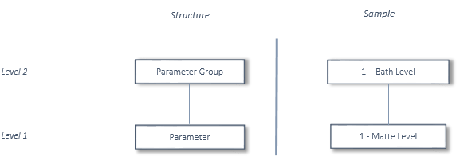

Definition of the hierarchy:

|  |  |  |  |  |  |  |  |
| --- | --- | --- | --- | --- | --- | --- | --- |
| **Level** | **Description** | **Definition** | **Parent Level** | **Structure** | | **Sample** | |
| **Identity** | **Alias** | **Identity** | **Alias** |
| 1 | Parameter | Monitored FSFE parameter | 2 | PRM_ID | PRM_ALIAS | 1 | Matte Level |
| 2 | Parameter Group | Category of the parameter |  | PRM_GRP_ID | PRM_GRP_ALIAS | 1 | Bath Level |

Parameter’s attributes:

|  |  |  |  |
| --- | --- | --- | --- |
| **Attribute** | **Definition** | **Structure** | **Sample** |
| Unit | Measurement unit of the parameter | PRM_UNIT | cm |
| Current Time Lag | Time lag of the parameter against to the matte tapping | PRM_TIME_LAG | 0 hours |
| Type | Indicates the type of the parameter :   * raw : directly extracted from the source system * calculated : calculated during the data loading | PRM_TYPE | raw |
| Source System | Indicates the source system of the parameter if its type is ‘raw’ | PRM_SOURCE_SYS | PI – Manual Entry |
| Source Object | Indicates the object corresponding to the parameter in the source system | PRM_SOURCE_OBJ | sme.fsfe.me-matte.li |
| Calculation | Indicates the calculation formula used during the data loading | PRM_CALCULATION |  |

List of all parameters: 

## **Axis of task**

The axis of task represents all tasks to be done that have been recorded in the Action Tracking tool for the FSFE Furnace department.

Leaf level: Task (*Identity*: TSK_ID, *Alias*: TSK_TITLE)

There is no hierarchy for this axis.

Task’s attributes:

|  |  |  |  |  |  |
| --- | --- | --- | --- | --- | --- |
| **Attribute** | **Definition** | **Structure** | | **Sample** | |
| **Identity** | **Alias** | **Identity** | **Alias** |
| Task Type | Type of the selected task | TSK_TSK_TYP_ID | TSK_TYP_ALIAS | 2 | Normal |
| Task Frequency | Frequency of the selected task | TSK_TSK_FRQ_ID | TSK_FRQ_ALIAS | 1 | Daily |

## **Axis of task’s department**

The axis of task’s department represents the department for which the task has been recorded in the Action Tracking tool and that must to be completed.

For now, only the FSFE department will be shown, but the axis could be extended to others departments if any.

Leaf level: Task’s department (*Identity*: DPT_ID, *Alias*: DPT_ALIAS)

Visualization of the hierarchy:

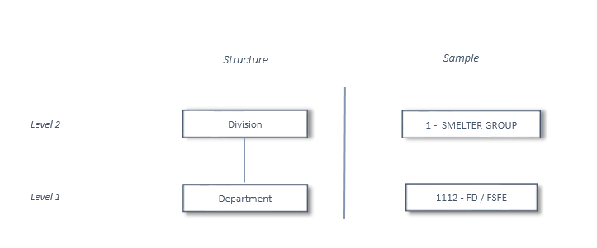

Definition of the hierarchy:

|  |  |  |  |  |  |  |  |
| --- | --- | --- | --- | --- | --- | --- | --- |
| **Level** | **Description** | **Definition** | **Parent Level** | **Structure** | | **Sample** | |
| **Identity** | **Alias** | **Identity** | **Alias** |
| 1 | Department | Department for which the task has been recorded | 2 | DPT_ID | DPT_ALIAS | 1112 | FD / FSFE |
| 2 | Division | Division of the task’s department |  | DPT_GRP_ID | GRP_DPT_ALIAS | 1 | SMELTER |

## **Axis of task frequency**

The axis of task frequency represents all frequencies of task defined in the Action Tracking tool.

Leaf level: Task Frequency (*Identity*: TSK_FRQ_ID, *Alias*: TSK_FRQ_ALIAS)

There is no hierarchy for this axis.

Description of all frequencies of task:

|  |  |
| --- | --- |
| **TSK_FRQ_ID** | **TSK_FRQ_ALIAS** |
| 1 | Daily |
| 2 | Weekly |

## **Axis of task type**

The axis of task type represents all types of task defined in the Action Tracking tool.

Leaf level: Task Type (*Identity*: TSK_TYP_ID, *Alias*: TSK_TYP_ALIAS)

There is no hierarchy for this axis.

Description of all types of task:

|  |  |
| --- | --- |
| **TSK_TYP_ID** | **TSK_TYP_ALIAS** |
| 1 | Debottle Neck |
| 2 | Normal |

## **Axis of task status**

The axis of task status represents all status that a task can have in the Action Tracking tool.

Leaf level: Task Status (*Identity*: TSK_STT_ID, *Alias*: TSK_STT_ALIAS)

There is no hierarchy for this axis.

Description of all status:

|  |  |
| --- | --- |
| **TSK_STT_ID** | **TSK_STT_ALIAS** |
| 1 | Open |
| 2 | Close |

## **Axis of employee**

The axis of task represents all PASAR employees in charge of completion of tasks recorded in the Action Tracking tool for the FSFE Furnace department. PASAR employees are grouped by departments then by divisions.

Leaf level: PASAR Employee (*Identity*: EMP_ID, *Alias*: EMP_FULLNAME)

Visualization of the hierarchy:

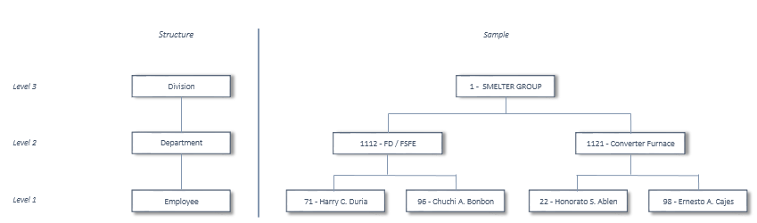

Definition of the hierarchy:

|  |  |  |  |  |  |  |  |
| --- | --- | --- | --- | --- | --- | --- | --- |
| **Level** | **Description** | **Definition** | **Parent Level** | **Structure** | | **Sample** | |
| **Identity** | **Alias** | **Identity** | **Alias** |
| 1 | Employee | Employee in charge of the task | 2 | EMP_ID | EMP_FULLNAME | 96 | Chuchi A. Bonbon |
| 2 | Department | Department of the task's employee | 3 | EMP_DPT_ID | DPT_ALIAS | 1112 | FD / FSFE |
| 3 | Division | Group of department |  | DPT_GRP_ID | GRP_DPT_ALIAS | 1 | SMELTER |

PASAR employee’s attributes:

|  |  |  |  |  |  |
| --- | --- | --- | --- | --- | --- |
| **Attribute** | **Definition** | **Structure** | | **Sample** | |
| **Identity** | **Alias** | **Identity** | **Alias** |
| Email | Email address of the employee in charge of the task | EMP_EMAIL | EMP_EMAIL | [cbonbon@pasar.com.ph](mailto:cbonbon@pasar.com.ph) | |
| Position | Position of the employee in charge of the task | EMP_PST_ID | PST_ALIAS | 14 | Manager 2 |

## **Axis of event type**

The axis of event type represents all types of event monitored in the RTDuet system (downtime, slowdown).

Leaf level: Event Type (*Identity*: EVT_ID, *Alias*: EVT_ALIAS)

There is no hierarchy for this axis.

Description of all types of task:

|  |  |
| --- | --- |
| **EVT_ID** | **EVT_ALIAS** |
| 1 | Primary |
| 2 | Secondary |

## **Axis of discipline**

The axis of discipline represents all fields of causes for downtimes or slowdowns.

Leaf level: Discipline (*Identity*: DSP_ID, *Alias*: DSP_ALIAS)

There is no hierarchy for this axis.

Description of all disciplines:

|  |  |
| --- | --- |
| **DSP_ID** | **DSP_ALIAS** |
| 1 | Civil |
| 2 | Electrical |
| 3 | Instrumentation |
| 4 | Mechanical |
| 5 | Operations |
| 99 | Unassigned |

## **Axis of TUC**

The axis of TUC (time usage code) represents all roots of downtimes or slowdowns.

Leaf level: TUC (*Identity*: TUC_ID, *Alias*: TUC_SHORTALIAS)

There is no hierarchy for this axis.

Description of all roots:

|  |  |  |
| --- | --- | --- |
| **TUC_ID** | **TUC_LONG_ALIAS** | **TUC_SHORT_ALIAS** |
| 2 | After Failure | After Failure |
| 3 | External Cause Downstream | Downstream |
| 4 | External Cause Upstream | Upstream |
| 5 | Operational Constraints | Operational |
| 6 | Preventive Maintenance | Preventive Maint. |
| 7 | Standby | Standby |
| 99 | Unassigned | Unassigned |

## **Axis of source asset**

The axis of source asset represents all machines for which slowdowns and downtimes are monitored. Machines are grouped by plant’s area then by site.

For now, only the FSFE furnace will be shown, but the axis could be extended to others machines if any.

Leaf level: Machine Centre (*Identity*: MCN_ID, *Alias*: MCN_ALIAS)

Visualization of the hierarchy:

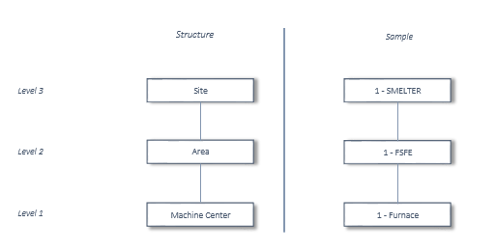

Definition of the hierarchy:

|  |  |  |  |  |  |  |  |
| --- | --- | --- | --- | --- | --- | --- | --- |
| **Level** | **Description** | **Definition** | **Parent Level** | **Structure** | | **Sample** | |
| **Identity** | **Alias** | **Identity** | **Alias** |
| 1 | Machine Centre | Monitored machine | 2 | MCN_ID | MCN_ALIAS | 1 | Furnace |
| 2 | Area | Area of the monitored machine in the plant | 3 | AST_ARE_ID | ARE_ALIAS | 1 | FSFE |
| 3 | Site | Site of the area in the plant |  | AST_SIT_ID | SIT_ALIAS | 1 | SMELTER |

## **Axis of reason**

The axis of reason represents all reasons of slowdowns and downtimes.

For now, only reasons for slowdowns and downtimes for the FSFE furnace will be shown, but the axis could be extended to others machines if any.

Leaf level: Reason (*Identity*: RSN_ID, *Alias*: RSN_ALIAS)

Visualization of the hierarchy:

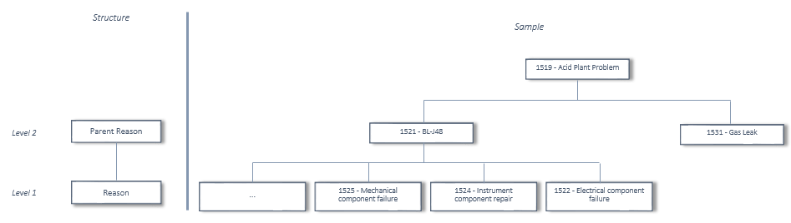

Definition of the hierarchy: it is a parent-child hierarchy

|  |  |  |  |  |  |  |  |
| --- | --- | --- | --- | --- | --- | --- | --- |
| **Level** | **Description** | **Definition** | **Parent Level** | **Structure** | | **Sample** | |
| **Identity** | **Alias** | **Identity** | **Alias** |
| 1 | Reason | Reason of the slowdown or the downtime | 2 | RSN_ID | RSN_ALIAS | 1531 | Gas Leak |
| 2 | Parent Reason | Parent node of the reason in the reason tree |  | RSN_PARENT_ID | RSN_ALIAS | 1519 | Acid Plant Problem |

# Measures

## **Measures of FSFE parameters**

**Gross Measures**

|  |  |  |  |  |  |
| --- | --- | --- | --- | --- | --- |
| **Measure** | **Definition** | **Unit** | **Source** | | **Aggregation** |
| Table | Field |
| Actual Value | Value of the parameter at the actual time | Depends on the parameter | DAT_FSFE_PRM | prm_actual_value | average |
| Synchronized Value | Value of the parameter at the synchronized time (*) | Depends on the parameter | DAT_FSFE_PRM | prm_sync_value | average |
| Time Lag | Time lag of the parameter against to the Matte tapping | Hour | DAT_FSFE_PRM | prm_time_lag | average |
| % Cu in Gran Slag | % Cu in Granulated Slag at the actual time | % Cu | DAT_FSFE_PRM | prm_fsgr_cu | average |
| Min Limit | Minimum value of the compliance range of the parameter | Depends on the parameter | DAT_FSFE_PRM | prm_range_min | average |
| Max Limit | Maximum value of the compliance range of the parameter | Depends on the parameter | DAT_FSFE_PRM | prm_range_max | average |
| Target | Target value of the parameter | Depends on the parameter | DAT_FSFE_PRM | prm_target | average |
| Compliant Value Nb | Number of values in the compliance range | Value | DAT_FSFE_PRM | prm_compliance | sum |
| Value Nb | Total number of recorded values for the parameter | Value | DAT_FSFE_PRM | prm_compliance | count |

**(*) synchronized time = value at (current selected time - time lag)**

**Calculated Measures**

|  |  |  |  |
| --- | --- | --- | --- |
| **Measure** | **Definition** | **Unit** | **Calculation** |
| % Compliance | % of compliant values on the total recorded values | % | [compliant value nb ]/ [value nb] x 100 |

## **Measures of FSFE tasks**

**Gross Measures**

|  |  |  |  |  |  |
| --- | --- | --- | --- | --- | --- |
| **Measure** | **Definition** | **Unit** | **Source** | | **Aggregation** |
| Table | Field |
| Task Nb | Number of recorded tasks | Task | DAT_TASK_HST | task_id | distinct count |

## **Measures of FSFE production**

**Gross Measures**

|  |  |  |  |  |  |
| --- | --- | --- | --- | --- | --- |
| **Measure** | **Definition** | **Unit** | **Source** | | **Aggregation** |
| **Table** | **Field** |
| Feed Volume | Volume of the FSFE Feed | Ton | DAT_FSFE_PRD | sync_fsfe_volume | sum |
| Copper Feed Volume | Volume of copper in the FSFE Feed | Ton | DAT_FSFE_PRD | sync_fsfe_cu_volume | sum |
| Dust Volume | Volume of Dust burnt with the FSFE Feed | Ton | DAT_FSFE_PRD | sync_dust_volume | sum |
| Copper Dust Volume | Volume of copper in the FSFE Dust | Ton | DAT_FSFE_PRD | sync_dust_cu_volume | sum |
| Granulated Slag Volume | Volume of Granulated Slag | Ton | DAT_FSFE_PRD | sync_grsl_net_volume | sum |
| Copper Gran. Slag Volume | Volume of copper in the Granulated Slag | Ton | DAT_FSFE_PRD | sync_grsl_cu_net_volume | sum |
| FSFE Matte Volume | Volume of FSFE Matte | Ton | DAT_FSFE_PRD | sync_fsfe_matte_volume | sum |
| Copper FSFE Matte Volume | Volume of copper in the FSFE Matte | Ton | DAT_FSFE_PRD | sync_fsfe_matte_cu_volume | sum |
| Calendar Time | Number of calendar hour | Hour | DAT_FSFE_PRD | calendar_time | sum |

**Calculated Measures**

|  |  |  |  |
| --- | --- | --- | --- |
| **Measure** | **Definition** | **Unit** | **Calculation** |
| Feed Rate | Volume of feed per hour | Tph | [feed volume] / [calendar time] |
| Weighted Cu in Feed | % of copper in the FSFE Feed | % | [copper feed volume] / [feed volume] x 100 |
| Dust Rate | Volume of Dust burnt per hour | Tph | [dust volume] / [calendar time] |
| Weighted Cu in Dust | % of copper in the FSFE Dust | % | [copper dust volume] / [dust volume] x 100 |
| Slag Rate | Volume of Granulated Slag generated per hour | Tph | [granulated slag volume] / [calendar time] |
| Ton Slag per Ton Charged Cu | Ton of Granulated Slag per charged ton of copper | Ton | [granulated slag volume] / ( [copper feed volume] +[copper dust volume] ) |
| Weighted Cu in Slag | % of copper in the Granulated Slag | % | [copper gran. slag volume] / [granulated slag volume] x 100 |
| Cu Recovery | Copper recovery of the total charged volume of copper | % | ( [copper feed volume] + [copper dust volume] – [copper gran. slag volume] ) x 100  ( [copper feed volume] + [copper dust volume] ) |
| Matte Rate | Volume of Matte generated per hour | Tph | [fsfe matte volume] / [calendar time] |
| Weighted Matte Grade | % of copper in the FSFE Matte | % | [copper fsfe matte volume] / [fsfe matte volume] x 100 |
| Matte Copper Rate | Volume of Matte Copper per hour | Tph | [copper fsfe matte volume] / [calendar time] |

## **Measures of FSFE slowdowns & downtimes**

**Gross Measures**

|  |  |  |  |  |  |
| --- | --- | --- | --- | --- | --- |
| **Measure** | **Definition** | **Unit** | **Source** | | **Aggregation** |
| **Table** | **Field** |
| Duration | Duration of slowdowns or downtimes | Minute | DAT_RTDUET | efduration |  |
| Equivalent Downtime | Duration of slowdowns or downtimes equivalent to a total stop time | Hour | DAT_RTDUET | eq_downtime_hrs |  |

**Calculated Measures**

|  |  |  |  |
| --- | --- | --- | --- |
| **Measure** | **Definition** | **Unit** | **Calculation** |
| Unassigned Time | Downtime duration without specified cause | Hour | [equivalent downtime] 🡺 [event type].[primary] 🡺 [tuc].[unassigned] |
| Stand By Time | Downtime duration due to standby | Hour | [equivalent downtime] 🡺 [event type].[primary] 🡺 [tuc].[stand by] |
| Upstream Time | Downtime duration due to external upstream causes | Hour | [equivalent downtime] 🡺[event type].[primary] 🡺 [tuc].[upstream] |
| Downstream Time | Downtime duration due to external downstream causes | Hour | [equivalent downtime] 🡺 [event type].[primary] 🡺 [tuc].[downstream] |
| Downtime After Failure | Downtime duration after failure | Hour | [equivalent downtime] 🡺 [event type].[primary] 🡺 [tuc].[after failure] |
| Downtime Operation Constraints | Downtime duration due to operation constraints | Hour | [equivalent downtime] 🡺 [event type].[primary] 🡺 [tuc].[operational] |
| Downtime Preventive Maintenance | Downtime duration due to preventive maintenance | Hour | [equivalent downtime] 🡺 [event type].[primary] 🡺 [tuc].[unassigned] |
| Slowdown Time | Slowdown duration | Hour | ( [duration] 🡺 [event type].[secondary] ) / 60 |
| Eq. Downtime From Slowdown | Slowdown duration equivalent to downtime | Hour | [equivalent downtime] 🡺 [event type].[secondary] |
| Disable Time | Total duration of downtimes due to downstream, upstream, failure, operation constraints and preventive maintenance | Hour | [upstream time] + [downstream time] + [downtime after failure] + [downtime operation constraints] + [downtime preventive maintenance] |
| Real Uptime | Duration without downtimes | Hour | [calendar time] – [disable time] |
| Operating Time | Duration during which the furnace works in a proper manner | Hour | [real uptime] – [stand by time] |
| Runtime @ Nominal Throughput | Duration during which the furnace is running properly | Hour | [operating time] – [slowdown time] |
| Operating Time @ Nominal Throughput | Duration during which the furnace is running at the budget feedrate | Hour | [operating time] – [eq. downtime from slowdown] |
| Plant Availability | Percentage of calendar time during which the operation of the furnace is not prevented by FSFE process difficulties | % | [operating time] + [stand by time] + [downstream time] + [upstream time]  [calendar time] |
| Plant Utilization | Percentage of calendar time during which the furnace is operating | % | [operating time] - [eq. downtime from slowdown]  [calendar time] |

# Scope of measures

For each measure or group of measures, the following table shows the lowest level of each axis that can be detailed (data granularity).

From data granularity, homogeneous data sets (cubes) are defined:

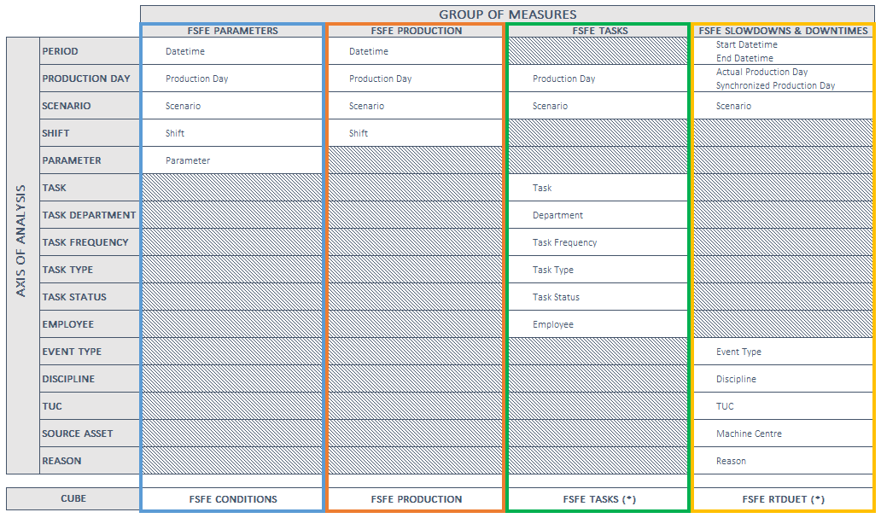

(*) Drilltrough actions will be defined to access to detailed data :

* For the fsfe tasks cube : access to the details entered for each task (task in details and remark)
* For the fsfe RTduet cube : access to the comment entered for each event (slowdown, downtime)

# Reports

## **FSFE daily process review**

|  |  |  |
| --- | --- | --- |
| **Purpose** | This report shows   * the performance of the FSFE Furnace process on a daily basis * the production of the FSFE Furnace on a daily basis * the percentage of the plant availability on a daily basis * the tasks captured from Action Tracker on a daily interval   This report must to highlight the daily performance of the process. | |
| **Adressee** | All defined users | |
| **Refresh frequency** | Daily | |
| **Broadcast mode** | SharePoint – Business Intelligence Centre | |
| **Data Source** | FSFE Conditions cube  FSFE Tasks | FSFE production cube  FSFE RTduet |
| **Report Type** | Preset report - Auto published report | |
| **Prompt** | Production Day | |
| **Export Format** | Excel | |
| **Sample** |  | |

## **FSFE weekly process review**

|  |  |  |
| --- | --- | --- |
| **Purpose** | This report shows   * the performance of the FSFE Furnace process on a daily basis for 7 days rolling * the production of the FSFE Furnace on a daily basis for 7 days rolling * the percentage of the plant availability on a daily basis for 7 days rolling * reasons of weekly downtimes * the tasks captured from Action Tracker on a weekly interval   This report must to highlight the weekly performance of the process. | |
| **Adressee** | All defined users | |
| **Refresh frequency** | Daily | |
| **Broadcast mode** | SharePoint – Business Intelligence Centre | |
| **Data Source** | FSFE Conditions cube  FSFE Tasks | FSFE production cube  FSFE RTduet |
| **Report Type** | Preset report - Auto published report | |
| **Prompt** | Production Day | |
| **Export Format** | Excel | |
| **Sample** |  | |

## **FSFE monthly process review**

|  |  |  |
| --- | --- | --- |
| **Purpose** | This report shows   * the performance of the FSFE Furnace process on a daily basis for the month * the daily compliance of the 7 main KPIs for the month * the production of the FSFE Furnace on a daily basis for the selected month * the percentage of the plant availability on a daily basis for the selected month * reasons of monthly downtimes   This report must to highlight the monthly performance of the process. | |
| **Adressee** | All defined users | |
| **Refresh frequency** | Monthly | |
| **Broadcast mode** | SharePoint – Business Intelligence Centre | |
| **Data Source** | FSFE Conditions cube  FSFE RTduet cube | FSFE production cube |
| **Report Type** | Preset report - Auto published report | |
| **Prompt** | Production Month | |
| **Export Format** | Excel | |
| **Sample** |  | |

## **FSFE daily off-gas handing review**

|  |  |
| --- | --- |
| **Purpose** | This report shows :   * the daily draft monitoring of the FSFE furnace * the daily EP performance * the daily dust generation and sulfurization * the daily temperature monitoring of the FSFE furnace |
| **Adressee** | All defined users |
| **Refresh frequency** | Daily |
| **Broadcast mode** | SharePoint – Business Intelligence Centre |
| **Data Source** | FSFE Conditions cube |
| **Report Type** | Preset report - Auto published report |
| **Prompt** | Production Day |
| **Export Format** | Excel |
| **Sample** |  |

# Prioritization of needs

In terms of priority, the reports should be developed in the following order:

1- the FSFE daily process review

2- the FSFE weekly process review

3- the FSFE daily off-gas handing review

4- the FSFE monthly process review